WEEK 4 – Microservices Architecture using ASP.NET Core Web API

Submitted By: Nishant Kumar
Superset ID: 7985565
College: C. V. Raman Global University, Odisha
Registration No.: 2301020208
Email: nishantkumar6205003458@gmail.com

Question 1: Implement JWT Authentication in ASP.NET Core Web API

Code:
using System;

using JwtMicroservice.Models; using Microsoft.AspNetCore.Mvc;
using Microsoft.IdentityModel.Tokens; using System.IdentityModel.Tokens.Jwt; using System.Security.Claims;
using System.Text;
namespace JwtMicroservice.Controllers
{
[ApiController] [Route("api/[controller]")]
public class AuthController : ControllerBase
{
[HttpPost("login")]
public IActionResult Login([FromBody] LoginModel model)
{
if (IsValidUser(model))
{
var token = GenerateJwtToken(model.Username); return Ok(new { Token = token });
}

return Unauthorized();
}

private bool IsValidUser(LoginModel model)
{
return model.Username == "admin" && model.Password == "password";
}

private string GenerateJwtToken(string username)
{
var claims = new[]
{
new Claim(ClaimTypes.Name, username), new Claim(ClaimTypes.Role, "Admin")
};
var key = new SymmetricSecurityKey( Encoding.UTF8.GetBytes("ThisIsASecretKeyForJwtToken"));
var creds = new SigningCredentials(key, SecurityAlgorithms.HmacSha256);

var token = new JwtSecurityToken( issuer: "MyAuthServer", audience: "MyApiUsers", claims: claims,
expires: DateTime.Now.AddMinutes(60), signingCredentials: creds);
return new JwtSecurityTokenHandler().WriteToken(token);
}
}
}

Output:
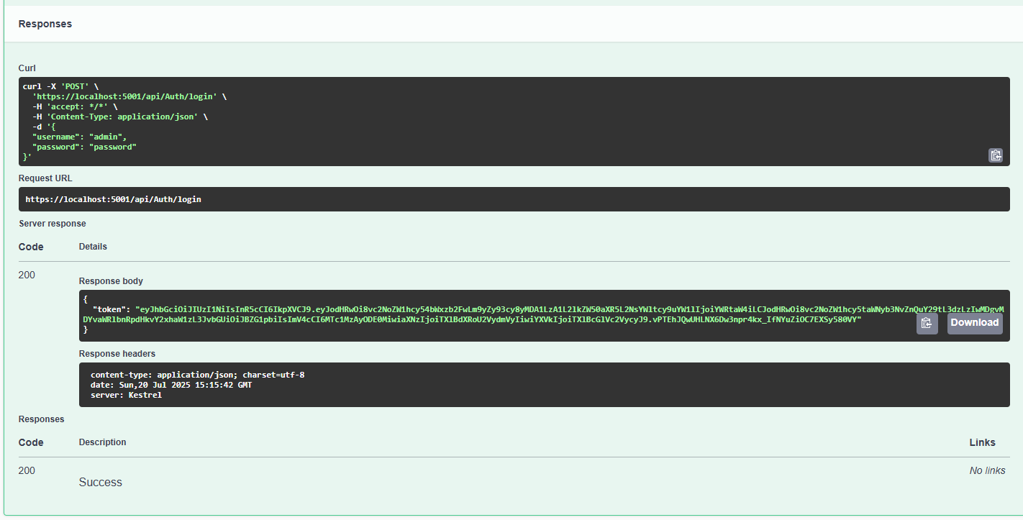

Question 2: Secure an API Endpoint Using JWT

Code:
using Microsoft.AspNetCore.Authorization; using Microsoft.AspNetCore.Mvc;
namespace JwtMicroservice.Controllers
{
[ApiController] [Route("api/[controller]")]
public class SecureController : ControllerBase
{
[HttpGet("data")] [Authorize]
public IActionResult GetSecureData()
{
return Ok("This is protected data.");
}
}
}

Output:

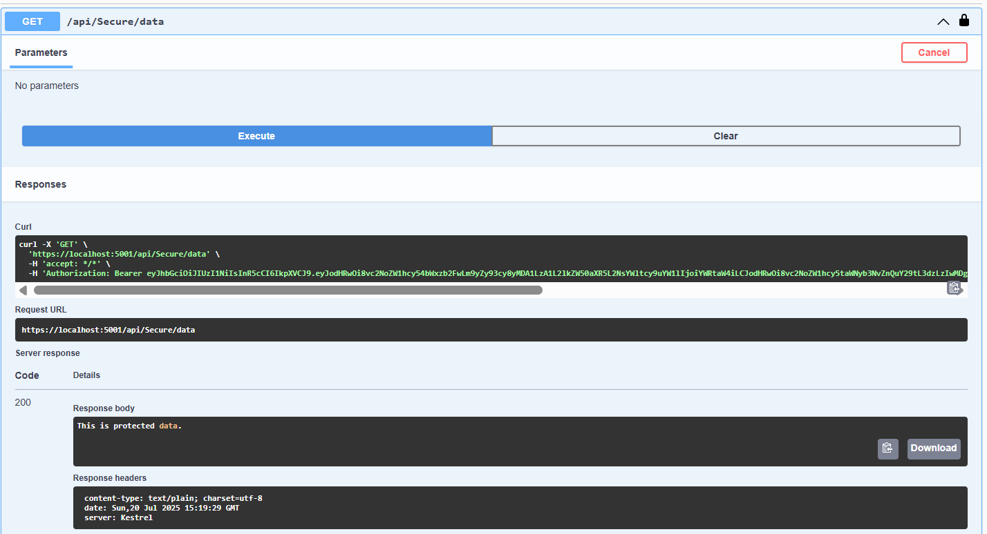

Question 3: Add Role-Based Authorization

Code:
using Microsoft.AspNetCore.Authorization; using Microsoft.AspNetCore.Mvc;
namespace JwtMicroservice.Controllers
{
[ApiController] [Route("api/[controller]")]
public class AdminController : ControllerBase
{
[HttpGet("dashboard")] [Authorize(Roles = "Admin")]
public IActionResult GetAdminDashboard()
{
return Ok("Welcome to the admin dashboard.");
}
}
}

Output:
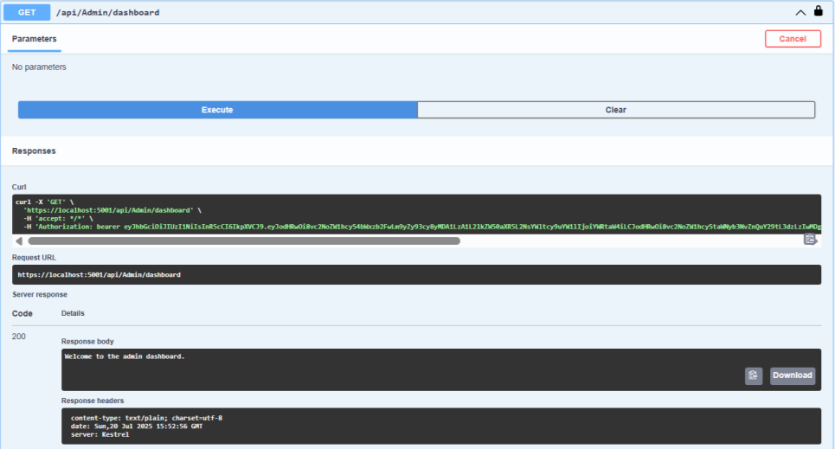

Question 4: Validate JWT Token Expiry and Handle Unauthorized Access

Code:
using Microsoft.AspNetCore.Authentication.JwtBearer; using Microsoft.IdentityModel.Tokens;
using Microsoft.OpenApi.Models; using System.Text;
using System.Threading.Tasks; using System;
var builder = Microsoft.AspNetCore.Builder.WebApplication.CreateBuilder(args);

builder.Services.AddControllers(); builder.Services.AddAuthentication("Bearer")
.AddJwtBearer("Bearer", options =>
{
options.TokenValidationParameters = new TokenValidationParameters
{
ValidateIssuer = true, ValidateAudience = true, ValidateLifetime = true, ValidateIssuerSigningKey = true,
ValidIssuer = builder.Configuration["Jwt:Issuer"], ValidAudience = builder.Configuration["Jwt:Audience"], IssuerSigningKey = new SymmetricSecurityKey(
Encoding.UTF8.GetBytes(builder.Configuration["Jwt:Key"]))
};

options.Events = new JwtBearerEvents
{
OnAuthenticationFailed = context =>
{
if (context.Exception is SecurityTokenExpiredException)
{
context.Response.Headers.Append("Token-Expired", "true");
}
return Task.CompletedTask;
}
};
});
builder.Services.AddAuthorization(); builder.Services.AddEndpointsApiExplorer(); builder.Services.AddSwaggerGen(c =>
{
c.SwaggerDoc("v1", new OpenApiInfo { Title = "JWT API", Version = "v1" });
c.AddSecurityDefinition("Bearer", new OpenApiSecurityScheme
{
Description = "JWT Authorization header using the Bearer scheme.", Name = "Authorization",
In = ParameterLocation.Header,
Type = SecuritySchemeType.ApiKey, Scheme = "Bearer"
});
c.AddSecurityRequirement(new OpenApiSecurityRequirement
{
{
new OpenApiSecurityScheme { Reference = new OpenApiReference {
Type = ReferenceType.SecurityScheme, Id = "Bearer"
}
},
Array.Empty<string>()
}
});
});

var app = builder.Build();

app.UseSwagger(); app.UseSwaggerUI();

app.UseAuthentication();

app.UseAuthorization();

app.MapControllers(); app.Run();

